Sunday | Monday | Tuesday | Wednesday | Thursday | Friday | Saturday
 |  |  |  | 1  May Day | 2 | 3
4 | 5  Cinco de Mayo | 6 | 7 | 8 | 9 | 10
11  Mother’s Day  National Skilled Nursing Care Week | 12 | 13 | 14 | 15 | 16 | 17  Armed Forces Day
18 | 19  Victoria Day (Canada) | 20 | 21 | 22 | 23 | 24
25 | 26  Memorial Day | 27 | 28 | 29 | 30 | 31

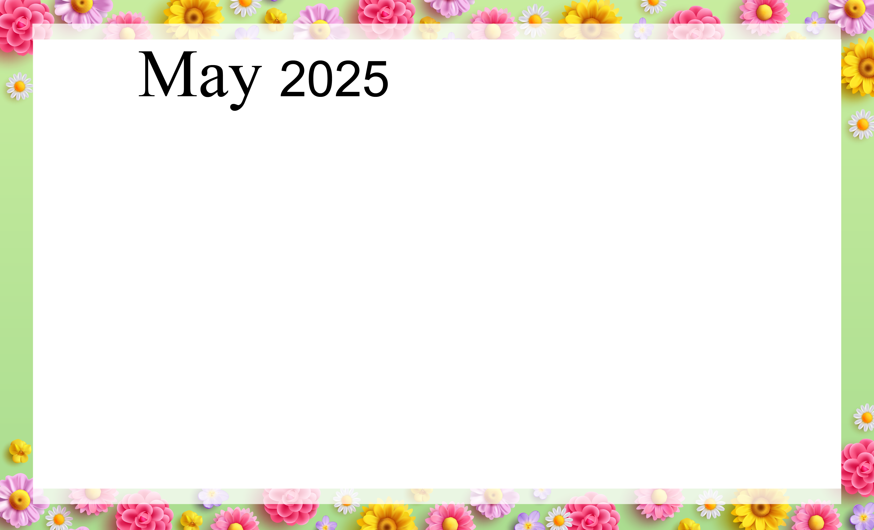  Willow Grove Recreation |  |  |  | 9:15 Jeopardy  10:00 Bowling  11:00 Bowling Continued  2:00 Bingo | 10:00 Arts and Crafts  11:00 Arts and Crafts continued  1:15 Word Game  2:00 Special Treat Cart  3:15 Strolls  6:30 Farkle Dice Game  Happy Birthday Marion! | 9:30 Morning Movie  2:00 Ball Trivia  3:00 Famous Faces
Therapy Dog Visits  10:00 Sunshine Strolls  11:00 Friendly Visits  1:30 Church Service and Communion (SV) | 9:15 Spiritual Program  10:00 Rummikub Game  11:00 Trivia  2:00 Bingo  3:00 Afternoon Devotional | 10:00 Mother`s Day Social with Birch Trail  11:00 Fun and Fitness  1:30 Waterways and Ports Presentation with Geneva Gillis (SV)  3:00 Bible Study (C)  3:15 Strolls  6:30 Mother`s Day Beading | 9:15 Word Searches  10:00 Donut Day  11:00 Strolls  1:15 Spring Drive Outing  2:00 Mother’s Day Arts and Crafts  3:00 Church Service (C) | 9:15 Colour by Number  10:00 Bowling  11:00 Fun and Fitness  1:30 Mother’s Day Tea Social with Rose (SV)  3:00 Hymn Sing (C) | 9:00 Clothing Boutique  10:00 Mother’s Day Baking Treat  11:00 Mother’s Day Baking Treat Continued  1:15 Hearing Clinic (Craft Room)  2:00 Special Treat Cart | 9:00 Mother’s Day Plant Sale  9:30 Morning Movie  2:00 Facts about Mother  3:00 Mother`s Day Word Searches
Therapy Dog Visits  10:00 Mother`s Day Colouring  11:00 Mother`s Day Trivia  1:30 Church Service and Communion (SV) | 9:15 Spiritual Program  10:00 Tissue Paper Crafting  11:00 Crafting Continued  2:00 Sunshine Strolls  3:00 Afternoon Devotional | 10:00 Pokeno  11:00 Fun and Fitness  1:15 Bread Baking  2:00 Card Game  3:00 Bible Study (C)  3:15 Table Games  6:30 Puzzles | 9:15 Hangman  10:00 Social Hour  with Ruth  11:00 Musical Memories (SL)  11:30 Bowling and McDonalds Outing  2:00 Trivia  3:00 Church Service (C) | 9:15 Trivia  10:00 Pizza Making Social with Birch Trail  11:00 Fun and Fitness  12:00 Pizza Lunch  2:00 Bingo  2:30 Giant Hymn Sing (SV)  Happy Birthday Tony! | 10:00 Hangman  11:00 Bean Bag Toss  1:15 Victoria Day Word Hunt  2:00 Special Treat Cart  3:15 Victoria Day Trivia  6:30 Patio Social Hour | 9:30 Morning Movie  2:00 Uno!  3:00 Strolls
Therapy Dog Visits  10:00 Table Games  11:00 Trivia  1:30 Church Service and Communion (SV) | 10:00 Victoria Day Crossword  11:00 Musical Memories (SL)  2:00 Sunshine Strolls | 10:00 Arts and Crafts  11:00 Fun and Fitness  12:00 Chinese Food Dine In  2:00 Victorian Fashion Show with Nancy (SV)  3:00 Bible Study (C)  3:15 Uno  6:30 Farkle Dice Game | 9:15 Yahtzee  10:00 Residents Council (C)  10:00 Baking  10:30 Butterfly Conservatory Outing  11:00 Baking Continued  2:00 Uno  3:00 Church Service (C) | 9:15 Short Stories  10:00 Bowling  11:00 Fun and Fitness  2:00 Bingo  7:00 Selkirk Christian Choir (SV) | 10:00 Pokeno  11:00 Strolls  1:15 Colouring  2:00 Special Treat Cart  3:15 Strolls  6:30 Puzzles | 11:00 Alzheimer’s Walk  3:00 Trivia
Therapy Dog Visits  10:00 Painting Flowers  11:00 Painting Continued  1:30 Church Service and Communion (SV) | 9:15 Spiritual Program  10:00 Table Games  11:00 Trivia  2:00 Patio Time  3:00 Afternoon Devotional | 10:00 Tabletop Bowling  11:00 Fun and Fitness  1:15 Crokinole  2:00 Birthday Party with Synchronicity (SV)  3:00 Bible Study (C)  3:15 Manicures  6:30 Arts and Crafts | 9:15 Bean Bag Toss  11:00 Caledonia Picnic Lunch Outing  2:00 Painting  3:00 Church Service (C) | 9:15 Giant Crossword  10:00 Bowling  11:00 Fun and Fitness  2:00 Bingo  3:00 Hymn Sing (C) | 10:00 Manicures  11:00 Word Searches  2:00 Carolinne Belles Entertainment (SV)  2:00 Special Treat Cart  3:15 Musical Memories (SL)  6:30 Spring Hangman | 9:30 Morning Movie  2:00 Pokeno  3:00 Outdoor Strolls
Birch Trail Birthdays: Richard (May 12th) & Roger (May 17th) C – Chapel SV – Southview SL – Small Lounge

